**Automation Anywhere, Data Aggregate Bot**

This project comes from my interest in large-scale data analysis. I've often wondered how competent different stock advice from websites was but could never collect enough data to form a reliable opinion. RPA gives the ability to collect such massive amounts of information to compare.

This bot logs into one of these websites, bar chart, and collects information from a downloaded list of around 5000 stocks. It does this by selecting a stock in alphabetical order and integrating that symbol name into a hyperlink for two different web pages.

One of these pages contains analyst opinions on that particular stock, and the bot scrapes these opinions and enters them into a second excel sheet. This page can have road bumps that could potentially stop the bot’s process. It’s been made more resilient by identifying these possible problems and implementing error handling. This can be seen on **video 1 a2019 aggregate**.

The second page contains stock pricing from 3 months back to the present, and these numbers are scraped to compare to the analyst opinion. This page has little to no issues so there is no need for error handling.

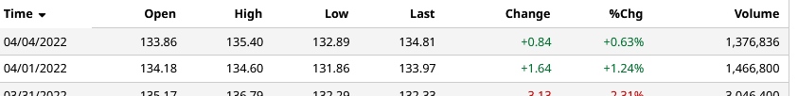

After the bot completes the entire list, it takes the excel information and enters them into a PostgreSQL server to be filtered after a few more months of collection. At any point in the process the bot can be stopped and resumed later and will begin where it had ended. This is shown on **video 2 a2019 aggregate.**

If the analyst opinions are valuable, then across such a large set of data, positive (buy) stock opinions should show a noticeable positive price movement across time.

**This project includes the use of the following action packages:**

* Database
* Excel advanced
* Systems (Environment variables)
* Numbers
* Loops
* Strings
* Simulate Keystrokes
* Recorder
* Ifs statements

**In this Bot:**

* The use and manipulation of statements for SQL.
* The modification of HTML selectors to gather dynamic data.
* The use of error handling for predicted and unpredicted challenges.